Task No 01:

Write a program that takes any integer as input, and then fulfill the following conditions:

- If input < 2, print input

- Else if input = 2, then halt

- Else if a > 2, then halt

Solution:

Output:

**- If input < 2, print input**

*Figure 1: Hardware View*

*Figure 2: Trace View*

**- Else if input = 2, then halt**

*Figure 1: Hardware View*

*Figure 2: Trace View*

Task No 02:

Write a program that takes any number as input, and then perform following calculations:

- If number < 10, add 100 in it and print the result.

- Else if number >=10, subtract 100 from it and print result.

Solution:

Output:

**- If number < 10, add 100 in it and print result**

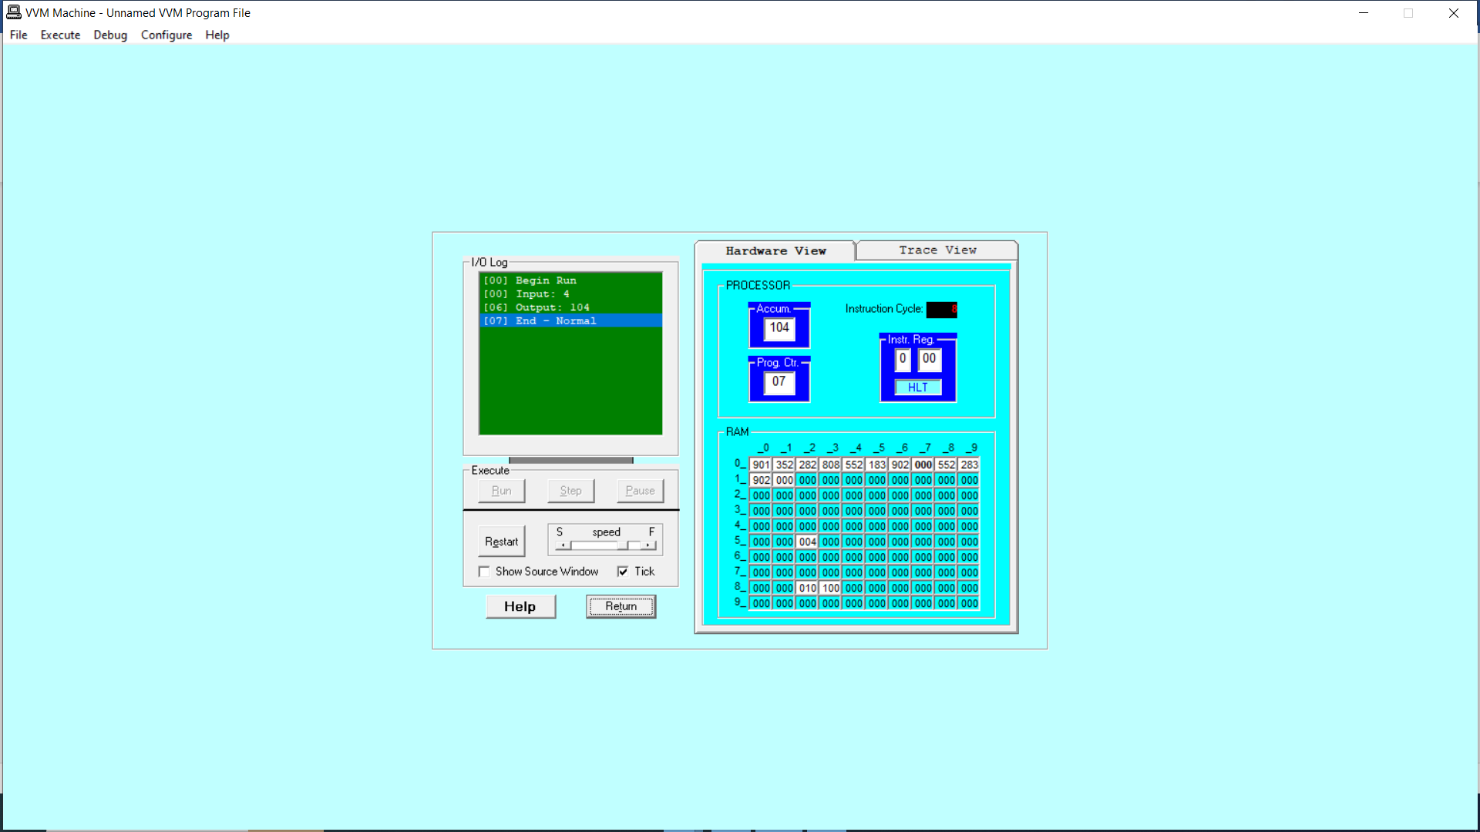

*Figure 1: Hardware View*

*Figure 2: Trace View*

**- Else if number >=10, subtract 100 from it and print result**

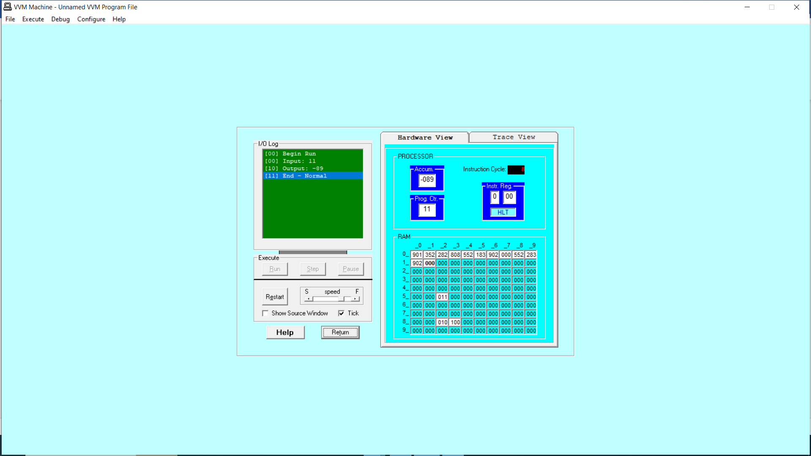

*Figure 1: Hardware View*

*Figure 2: Trace View*

Task No 03:

Write a program that takes two numbers as input and then print the smaller one.

Solution:

Output:

*Figure 1: Hardware View*

*Figure 2: Trace View*

Task No 04:

Write a program that takes two hardcoded values, and then print the larger one.

Solution:

Output:

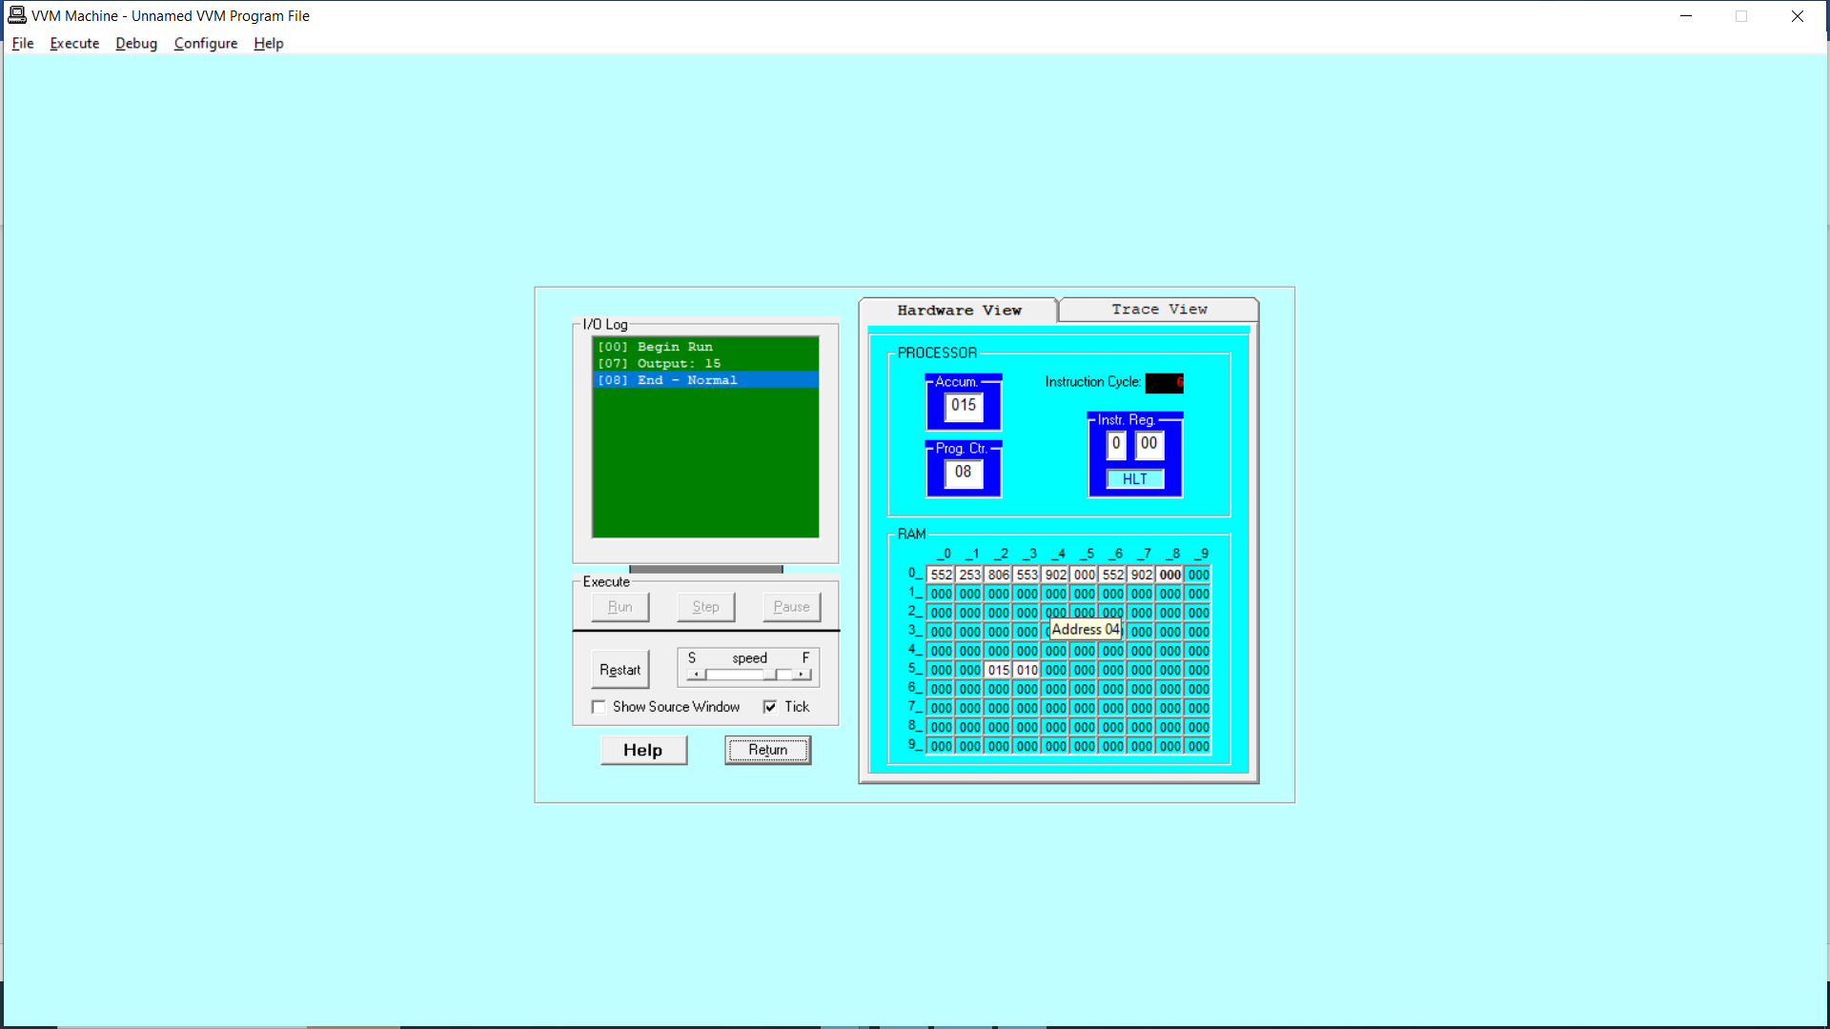

*Figure 1: Hardware View*

*Figure 2: Trace View*